**CS 131C# - Beginner**

**HOP07 – Date and Time Handling**

2/17/2020 Developed by Kim Nguyen

Center for Information Assurance (CIAE) @City University of Seattle (CityU)

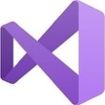

**Before You Start**

* Version numbers may not match with the most current version at the time of writing. If given the option to choose between stable release (long-term support) or most recent, please choose the stable release rather than beta-testing version.
* This tutorial targets Windows users and MacOS users.
* There might be subtle discrepancies along the steps. Please use your best judgement while going through this cookbook style tutorial to complete each step.
* For your working directory, use your course number. This tutorial may use a different course number as an example.
* The directory path shown in screenshots may be different from yours.
* If you are not sure what to do or confused with any steps:
  1. Consult the resources listed below.
  2. If you cannot solve the problem after a few tries, ask a TA for help.

**Learning Outcomes**

Students will be able to:

* Understand and useDateTime class and library in C#.
* Use DateTime library to write simple programs.
* Manipulate DateTime types with other variable types.

**Resources**

* C# Tutorial | Freecodecamp.org- <https://youtu.be/GhQdlIFylQ8>
* C# Tutorials | W3Schools.com- <https://www.w3schools.com/cs/default.asp>
* C# Documentations | Microsoft.com - <https://docs.microsoft.com/en-us/dotnet/csharp/>
* Library | Webopedia.come - <https://www.webopedia.com/TERM/L/library.html>
* C# Tutorials | tutorials.com- [https://www.tutorialspoint.com/csharp/](https://www.tutorialspoint.com/csharp/csharp_strings.htm)

At this point, you have been able to write small programs using user-define functions, arithmetic calculations, etc.

However, like every other programming languages, there are built-in libraries and functions that saves your time and makes programming more convenient. In this week's HOP, we will get familiar with Date and Time library to write more powerful programs.

"In programming, a library is a collection of precompiled routines that a program can use. The routines, sometimes called modules, are stored in object format. Libraries are particularly useful for storing frequently used routines because you do not need to explicitly link them to every program that uses them."

**Create a project**

1. Open Visual Studio.
2. File > New > Project
3. Select Console App (.NET Core), click Next
4. Type “Date-Time” in the Project name and save it in the following locations:

**If you are an online student:**

Save it here > CS131-Winter-2020\**ON**\FirstnameLastname/Module7/Date-Time

**If you are an onsite student:**

Save it here > CS131-Winter-2020\**IN**\FirstnameLastname/Module7/Date-Time

1) Type the following in your Program.cs:

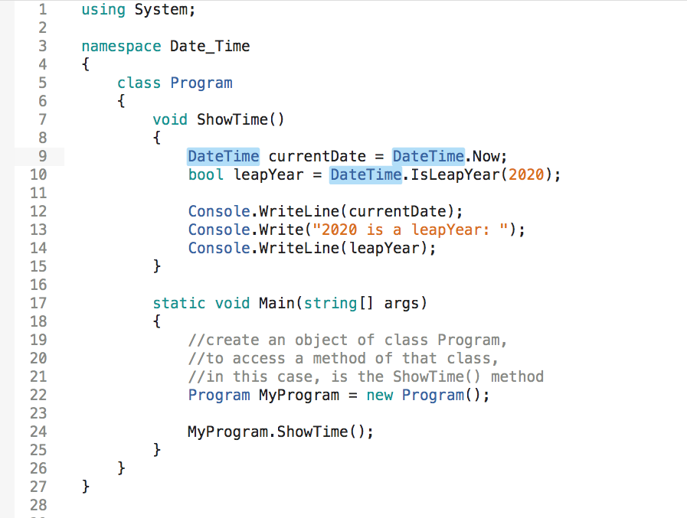

2) Run your program, you should see today's date has been autogenerated and 2020 is checked whether a leap year or not:

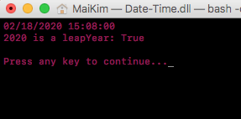

(Note: The time displayed on the screen is the time of program execution. You should see a different date and time depending on when you run your program)

ShowTime() is a user-defined method, that I wrote by myself, while DateTime came from a library that has already been provided inside C#. To read more about that library, right click on DateTime -> Go to Defintion/ Go to Declaration -> another tab linking to DateTime source code class will be opened:

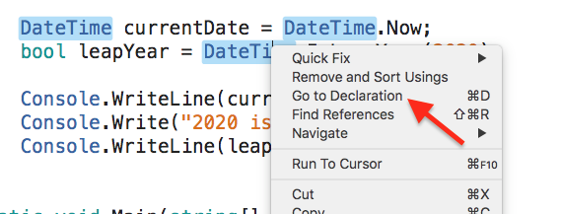

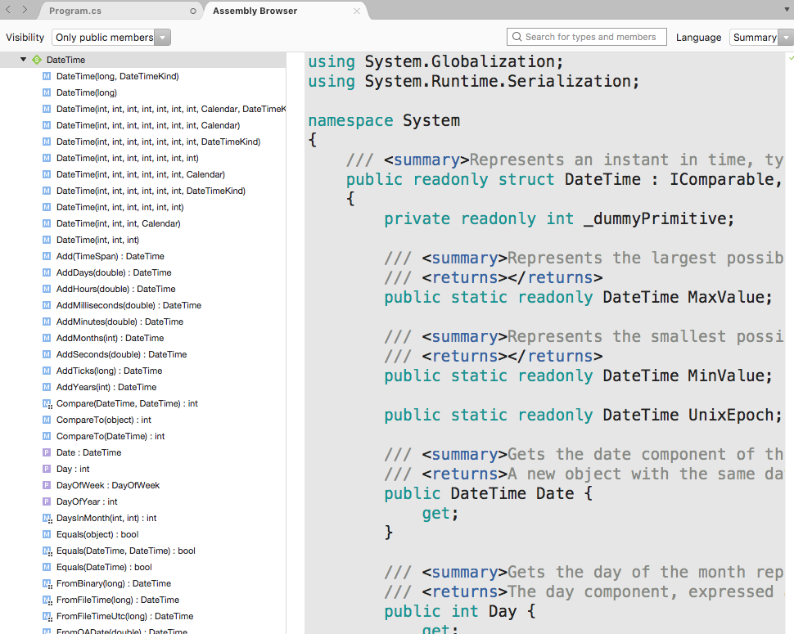

3) Let's use more DateTime library and what we have known before to practice more. Update your Program.cs to match the following screenshot:

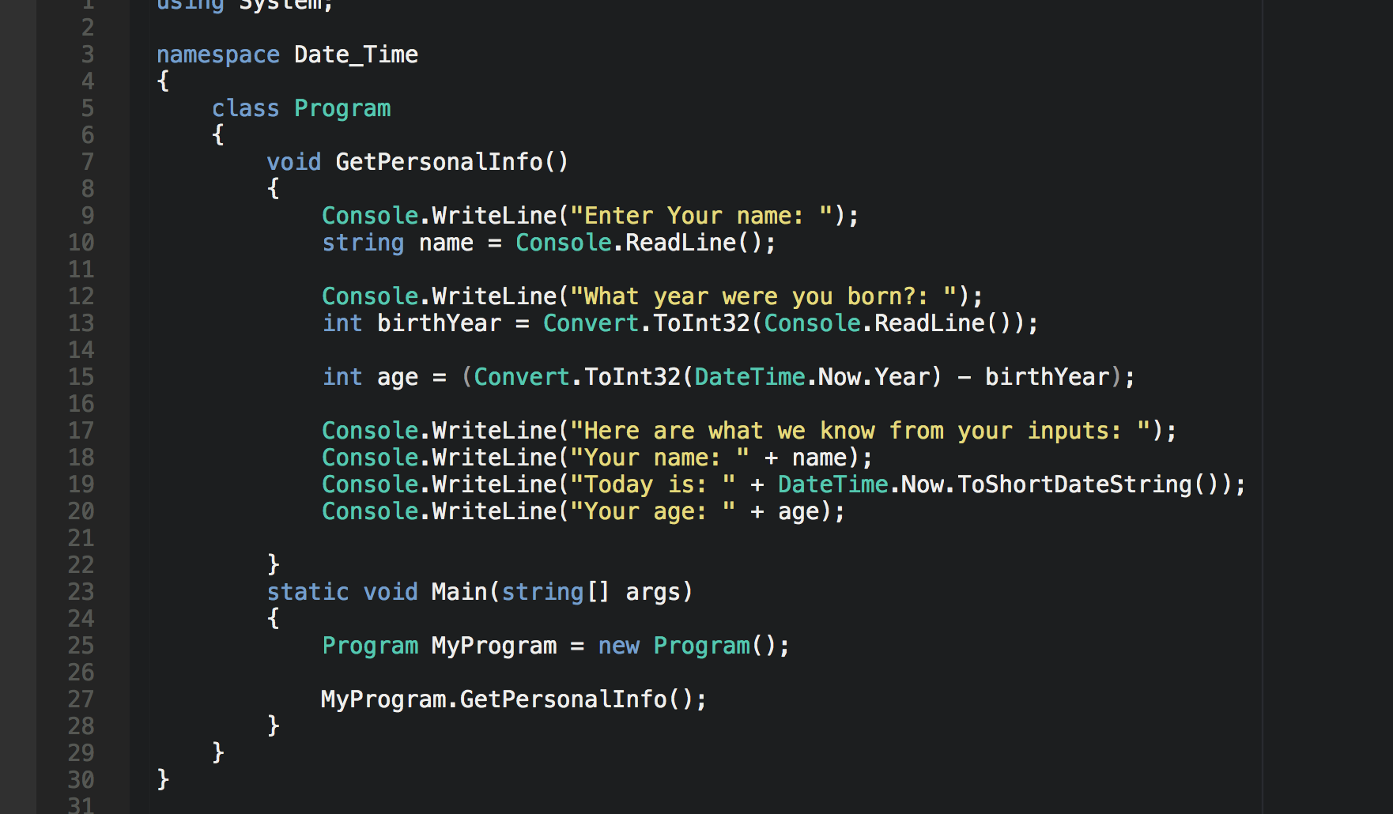

4) Run your program:

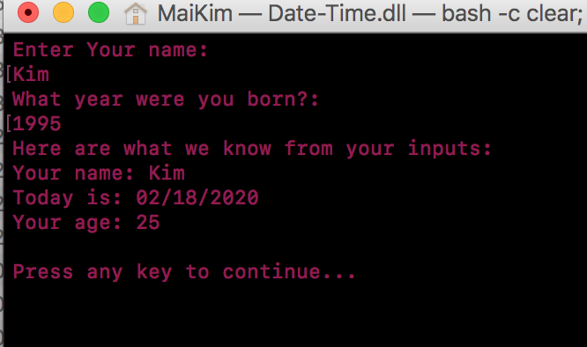

**CHALLENGE:**

Get this current month, print on screen

Get number of days of this month, print on screen.

Expected output:

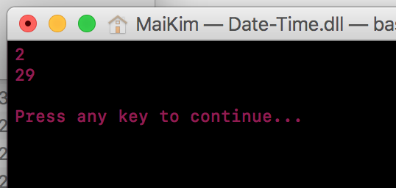

**Push your work to GitHub**

**Commit changes**

1. Click on the **Home** button > **Changes**
2. Type commit message
3. Select **Commit All and Push**

**Create a pull request**

1. Go to your fork page on GitHub website
2. Near the top left side, change the active branch to your new branch
3. Click on the "New Pull Request" button next to the branch name.